

Fig.1 Sparse dot of locust slice image



Fig.2 Sparse dot of image

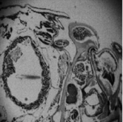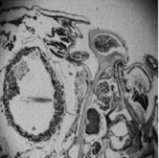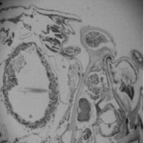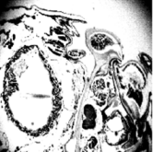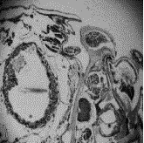

100.8435 120.8700 132.0517 138.858 140.7738 152.507 158.5068 162.6798

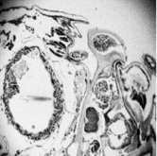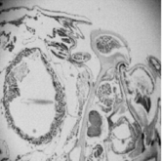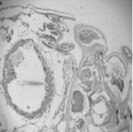

166.8633 170.9073 176.7876 182.8212 188.301 200.3745 206.7993 210.0153

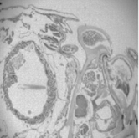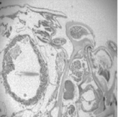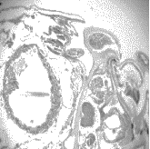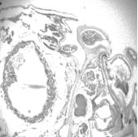

213.3423 218.9478 222.1863 226.1811 238.2291 238.5864 241.1343 244.455

Fig.3 Original image with different contrast rate



100.8435 120.8700 132.0517 138.858 140.7738 152.507 158.5068 162.6798



166.8633 170.9073 176.7876 182.8212 188.301 200.3745 206.7993 210.0153



213.3423 218.9478 222.1863 226.1811 238.2291 238.5864 241.1343 244.455

Fig.4 Add the same level of Gaussian noise



100.8435 120.8700 132.0517 138.858 140.7738 152.507 158.5068 162.6798



166.8633 170.9073 176.7876 182.8212 188.301 200.3745 206.7993 210.0153

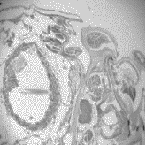

213.3423 218.9478 222.1863 226.1811 238.2291 238.5864 241.1343 244.455

Fig.5 image after denoising with different contrast rate

   

a original image b Images with salt and pepper c Sparse interpolation operator d Sparse dot

Fig.6 Sparse interpolation operator denoising



(a)original image (b)Images with salt and pepper noise (c)Image with 1 iteration



(d)Image with 2 iteration (e)Image with 3 iteration (f)Image with 4 iteration

Fig.7 Increase in the number of iterations

   

(a)original image (b)Noise image (c)median filtering (d)Mean filtering

   

(e)Wiener filtering (f)wavelet transform (g)Gauss filtering (h)Bilateral filtering

   

(i)The combination of median and Wiener filte (j)The combination of median and wavelet (k)Edge unpreserving algorithm (l)Algorithm in this paper

Fig. 8 Comparison of various algorithms after denoising



Fig.9 PSNR comparison of different algorithms under different Salt and pepper noise levels

   

(a)original image (b)Noise image (c)median filtering (d)Mean filtering

   

(e)Wiener filtering (f)wavelet transform (g)Gauss filtering (h)Bilateral filterin

 

1. The combination of median and Wiener filte (j)Algorithm in this paper

Fig. 10 Comparison of various algorithms after denoising



Fig. 11 PSNR comparison of different algorithms under different gaussian noise levels



(a)original image (b)Noise image (c)median filtering (d)Mean filtering



(e)Wiener filtering (f)wavelet transform (g)Gauss filtering (h)Bilateral filtering



(i)The combination of median and Wiener filter (j)The combination of median and wavelet (k)Edge unpreserving algorithm (l)Algorithm in this paper

Fig.12 Comparison of various algorithms after denoising



Fig.13 PSNR comparison of different algorithms under different mixed noise levels